EVEN THE GREAT NIKOLA TESLA WOULD HAVE BEEN A REFUGEE TO CANADA TODAY

By courtesy of the Embassy of the Republic of Serbia to Canada
August 2017

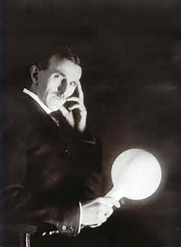
Nicola TESLA
(photo circa 1920)

In the present-time Europe, the word "refugee" is immediately associated with millions of people from the Middle East. With those already in Europe, estimated to more than 1 million or those still in refugee camps in Turkey, some 2.7 millions. Migrants, asylum seekers - false or real, young economic migrants who want a better life and are ready to risk it crossing the Mediterranean by paddling. Or even terrorists sneaking in from the war zones of Syria and Iraq.

However, even by today's world refugee fatigue standards, the exodus of 250,000 people in only 4 days would have been breaking news. If you add 2,313 killed by regular army or police forces - someone would certainly have to prepare to be heavily bombed. Of those killed 522 women and 12 children - enough for an extraordinary session of the Security Council to be urgently summoned. A vote on international sanctions - included. More then 20.000 homes deliberately set on fire, a ``smoking gun`` for full media coverage going ``live``, with the world of NGO and social networks going viral or at the brink of implosion.
This is what happened to Serbs in Croatia on 5 August 1995. Operation "Storm" - an ugly, forgotten exodus. Not to come back. Ever. In total, some 400,000 Serbs less in Croatia in 2011 census - then in 1991.

Some of the above mentioned world reactions eventually did happen. Too little, too late. The ad hoc Tribunal for the former Yugoslavia qualified this as war crime, and ``joint criminal enterprise`` of Croatia against Serbs - its own citizens. However, back then the Croatian President Tudjman died just in time not to be indicted and a couple of Croatian generals, after being in prison for 5-6 years, were acquitted. Basically, for not shelling as hard as they could. Most of the world powers involved in this conflict in one way or another were eager to close the chapter of civil war in the Balkans and dismemberment of Yugoslavia. They often did it also by opting between the ``good``, the ``bad`` or the ``useful`` nationalisms of belligerent nations - of Bosniaks, Croats or Serbs. Therefore, when Croatia celebrates the macabre ``anniversary``, foreign diplomats in Zagreb are shy. Some refuse to associate their national flags with the military parade on that date, like the US or Germany did two years ago. Attendance is often delegated to lower diplomatic ranks.

Croatia will, however, celebrate its military-police operation this year again. Kind of a blitzkrieg. Serbia will mourn. Mourn, but also remember how Canadians bravely tried to save them in what was a prelude or general rehearsal for Operation ``Storm`` - the so called ``Medak Pocket`` Operation - just two years before, in September 1993, when Canadian soldiers in the UN Peacekeeping Mission unfortunately experienced what it was like to be Serb in Croatia in those days. Four Canadians wounded in artillery shelling of Croatian armed forces. Two more wounded and one dead in the immediate chaotic aftermath. Under the command of LCol. James Calvin they responded with all firepower resulting in 27 Croatian soldiers killed. First confirmed, then denied by Croatia. They were fighting for their lives and to save Serbian civilians as well, with conviction and commitment. However, they could not save 88 of them. So, Serbs in Canada on this 5 August will mourn but will also honour the bravery of Canadian soldiers. 875 of them from 2nd Battalion Princess Patricia's Canadian Light Infantry Battle Group. As the Governor General Adrienne Clarkson did with the Commander-in-Chief Unit Commendation for this unit in 2002. The award created to recognize outstanding service of soldiers who come under direct fire. Biggest Canadian Battle between Korean War and Afghanistan Campaign.

Commemorations will take place in Serbian communities across Canada - from Burlington to Barnaby, in Kelowna or Kitchener, Montreal or Milton. In 26 Serbian churches and monasteries across the country. With both the Serbian and Canadian flag in hand.

Let's not forget the great scientist Nikola Tesla. A Serb, like all the 250,000 expelled in 1995, born in village of Smiljan in Croatia, a son of the local Serbian orthodox priest. The house he lived in was burned twice in last century. First by Nazi allies Croatian Ustashi in 1941, then again by Croatian soldiers in 1995. You can guess his fate if he had been born a couple of decades later (he was actually born in 1856) to experience the 1995 exodus. The ugly, forgotten one.

Yet, something else would have likely happened, having in mind his education. Being an engineer, he would have probably silently chosen to come to Canada as a refugee. Just like so many others in those days that even today have nowhere to go back to.

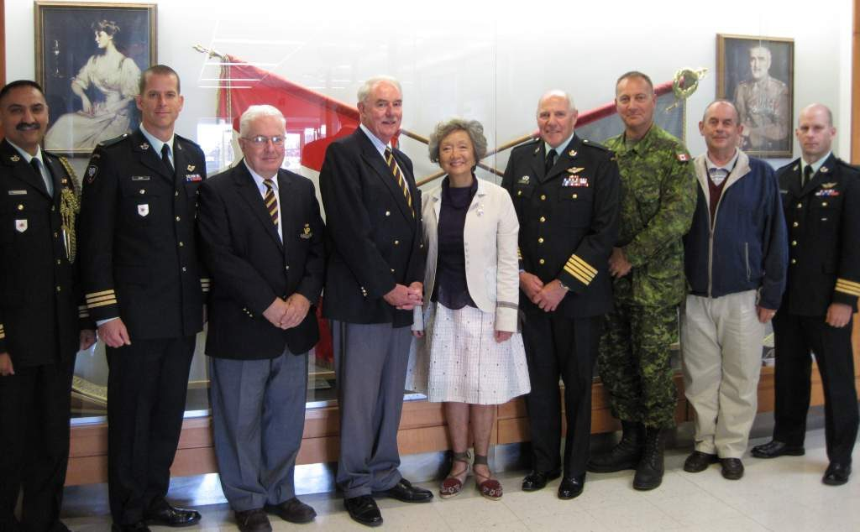

The founding trustees of the Foundation on 27 August 2010 with the Foundation's Patron the Right Honourable Adrienne Clarkson Colonel-in-Chief PPCLI, and LLieutenant-General (Ret'd) Ray Crabbe, Vice-Patron and Colonel of the Regiment

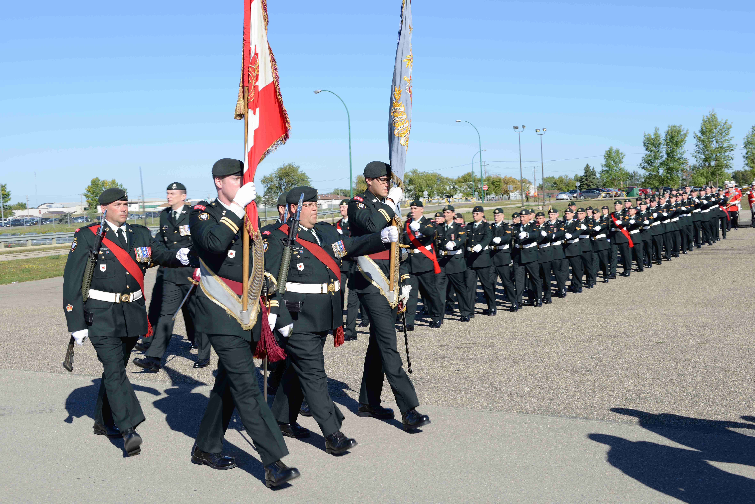

Princess Patricia's Canadian Light Infantry (PPCLI)
Members of the PPCLI parade in 2013 to commemorate the 20th anniversary of the unit's involvement in the Battle of Medak Pocket, in the former Yugoslavia. (DEPARTMENT OF NATIONAL DEFENCE, COMBAT CAMERA)

