

Mihailo Papazoglu: Serbia and Canada, fighting on the right side of history

Special to National Post | July 28, 2014 6:00 AM ET
More from Special to National Post
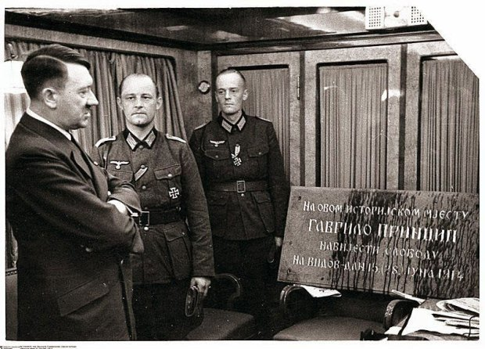
Adolf Hitler examines the plaque commemorating Gavrilo Princip's assassination of Archduke Franz Ferdinand, which was removed from Sarajevo by German troops and presented to him on his 52nd. birthday in 1941. The photograph was taken by Hitler’s personal photographer, Heinrich Hoffmann.

Sarajevo, June 28, 1914. After 400 years under Turkish Ottoman and almost 40 under Austro-Hungarian occupation, people of some dozen different nationalities share the same dream of freedom — Gavrilo Princip among them. He shoots Austria’s Crown Prince. To many of his countrymen, he is a freedom fighter. A tiny few consider him a terrorist. Let’s leave a question mark there for now. But the shots did announce the beginning of warfare. They were a memento mori.
Belgrade, July 28, 1914. Just a month later, under the burning summer sun, the first artillery shells fall on the Danube and Sava riverbanks, and then onto the city itself. For Serbia, it is the end of a month-long diplomatic prelude that began with Princip’s shots. Austro-Hungary, an empire of 52 million people, gave a 48-hour ultimatum to a nation of five million. The declaration of war was sent by telegraph. There was nowhere to hide.
You have probably never heard of Dušan Đonović. He was a 16-year-old Serbian Army volunteer, born in Crmnica, shot in Belgrade by an Austrian Danube Flotilla vessel that very first day of the war. He was its first victim. He would soon be joined in death by 1.25 million other Serbs — 28% of the total population, soldiers and civilians alike.
You may, however, have heard of George Lawrence Price. Born in Falmouth, N.S., he served in Belgium with A Company of the 28th Battalion of the Canadian Expeditionary Force. On Nov. 11, 1918, at 10:58 a.m., just two minutes before the Armistice, he was fatally shot by a German sniper. He was the last victim of the war, which claimed the lives of 61,000 of his fellow Canadians, and 17 million people in Europe and around the world.
In between, the Serbs fought — for a year on our soil, on our frontiers, mostly alone. The first Allied victory took place in Serbia in 1914, in the mountains of Cer, then the second in Kolubara. It was something like Vimy Ridge: The success drew worldwide attention to Serbia and won the Serbs the sympathy and gratitude of both neutral and Allied countries.
The next year, we had our share of defeats. Belgrade was the last stand for more than 2,600 Serbian soldiers, who defended the capital knowing Army Headquarters had already erased their names from the list of the living. They were left behind as an ultimate sacrifice, but have never been forgotten. (Ask any kid in Serbia today. They know about it!) We survived with barely enough strength to man the trenches of the so-called Salonika Front, in Greece — an experience not unlike what the Canadians endured at Passchendaele.
But eventually, the Central Powers proved too much. We were overwhelmed and occupied for three years, but we never lost faith. We lost a country, but we saved the state. The population was left to occupiers, but we saved the nation. And finally, in 1918, along with our allies, the Serbian Army won its country back.
And where was Gavrilo Princip? Imprisoned in the dungeon of the fortress in Theresienstadt — Terezin in today’s Czech Republic — which the Nazis later used as a concentration camp. The majority of its 150,000 prisoners were sent to extermination camps, while some 33,000 died there from starvation or disease. Princip suffered the same fate: He officially died from tuberculosis, with his arm and shoulder amputated.
An underage self-proclaimed freedom fighter, he never got to see the armistice, and the liberation for which he gave his life. He had died six months earlier and was buried in a secret location, in hopes his body would never be found. Why did it all happen? Simply because he refused to go from being a Turkish Ottoman subject to an Austro-Hungarian subject, from a Middle East model of apartheid to a Mitteleuropa one.
The photo above depicts a marble plate, installed after the war at the very spot in Sarajevo where Crown Prince Ferdinand was shot. “On this historic place, Gavrilo Princip foreboded freedom,” it reads in Serbian. And look who is regarding it with an expression of accomplished revenge. Seized in the first days of the Nazi occupation of Yugoslavia in 1941, it was delivered to Adolf Hitler on his birthday. He called it “a symbol of German humiliation.”
Serbia and Canada fought on the same side of history, for the right cause. The aftermath of the First World War saw Canada achieve full independence and Serbia full self-confidence in the international arena of the time. Serbia, along with others, paid a high price in human life. Collective memory of the war became the cornerstone of our respective nations’ identities. And we fought again on the same side in the Second World War.
Now globalization and the modern world have made us neighbours. Let’s ensure the future seals this partnership.
Mihailo Papazoglu is Serbian ambassador to Canada.

http://fullcomment.nationalpost.com/2014/07/28/mihailo-papazoglu-serbia-and-canada-fighting-on-the-right-side-of-history/

