

Opinion: A defining war for Serbia

Like Canada, Serbia emerged from the First World War with a different perception of itself and its place in the world
By H. E. Mihailo Papazoglu August 4, 2014

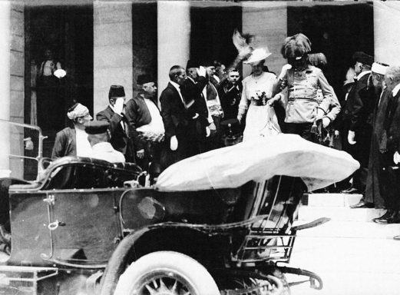
Archduke Franz Ferdinand and his wife Sophia get into their car outside Sarajevo city hall on June 28, 1914, minutes before their assassination. Their shooting deaths, carried out by 19-year-old Bosnian-Serb nationalist Gavrilo Princip, is widely considered to have sparked what became the First World War.
A little more than 100 years ago, the first shells of the First World War began to fall on the neighbourhoods around Serbia’s Danube and Sava rivers. Dušan Ðonović, a 16-year-old Serbian Army volunteer, became the first victim of that war. The last victim was a Canadian, George Lawrence Price. The 26-year-old from Falmouth, N.S., was fatally shot by a German sniper at 10:58 a.m. on Nov. 11, 1918, in Belgium. He died just two minutes before the armistice ceasefire that ended the war began at 11 a.m.
Canada, Serbia and their First World War allies — the United Kingdom, France, Russia, the United States, Italy, Greece, Romania and Belgium — were all on the same side of history.
In fact, a Serb triggered the war, the country was an important battleground for the conflict, and the price the country paid was overwhelming: My country’s military and civilian death toll was 1.25 million, 28 per cent of the total population. The fatal shooting of Austria’s Crown Prince Franz Ferdinand and his wife on June 28, 1914, in Sarajevo was the trigger for the war, one of the deadliest conflicts in history.
To some, the shooter, Gavrilo Princip, was a terrorist. But to many of his countrymen, he was a freedom fighter. At the time Bosnia and Hercegovina was occupied by the Austro-Hungarian Empire, after having endured 400 years under Turkish Ottoman occupation. Its people of some dozen different nationalities shared a dream of freedom. After the assassination, Austria-Hungary delivered an ultimatum to Serbia. An empire of 52 million people gave a 48-hour ultimatum to a nation of 5 million. There was nowhere to hide. The declaration of war was sent by an urgent telegraph message.
The Serbs fought for one year on their soil on their frontiers, mostly alone. The first allied victory took place in Serbia, in the mountains of Cer. The second one took place in Kolubara — almost like the battle of Vimy Ridge. This success drew worldwide attention to Serbia and won the Serbs sympathy of both neutral and Allied countries, as it marked their first victory over the Central Powers. The next year the Serbs had their share of defeats. Belgrade, the capital, was the last stand for more than 2,600 Serbian Army soldiers who defended it. They were aware of the fact that their names had already been erased from the list of the living by Serbian Army headquarters; they were left behind as an ultimate sacrifice. But not to be forgotten — ask any kid in Serbia today about this incident.
Once again the Serbs survived barely enough to align in trenches of the so-called Salonica Front in Greece, an experience similar to what the Canadians endured at Passchendaele. For those three years of war in exile Serbian soldiers lost a country, but saved the state and the statehood. The population was left to occupiers — but they saved the nation. They never lost faith. Finally, along with our allies, in 1918 we were free.
And what was Gavrilo Princip doing at that time? He was imprisoned in the dungeon of the fortress in Theresienstadt (Terezin in today’s Czech Republic). Gavrilo officially died from tuberculosis, with his arm and shoulder amputated. An underage self-proclaimed freedom fighter, he never got to see the Armistice in 1918 and the liberation he gave his life for. He died six months earlier and was secretly buried, so that his body would never be found.
Serbia and Canada fought on the same side of history, for a just cause. The aftermath of the First World War led Canada to full independence and Serbia to full self-confidence in the international arena of that time. Serbia, along with others, paid a high price in human lives during the war — never to recover, some say. Collective memory of the First World War has become a cornerstone of our respective nations’ identities.
History made Serbia and Canada allies in both world wars. Modern world and globalization made us neighbours. Let’s make the future seal this partnership.
Mihailo Papazoglu is the Serbian ambassador to Canada.
http://www.montrealgazette.com/news/Opinion+defining+Serbia/10089177/story.html

